# CS 255 System Design Document Template

This template lays out all the different sections that you need to complete for Project Two. Each section has guidance to prompt your thinking. You will need to continually reference the interview transcript as you work to make sure that you are addressing your client’s needs. There is no required length for the final document. Instead the goal is to complete each section based on what your client’s needs are. Remove this note when you are finished, and replace all bracketed text with the relevant information.

## UML Diagrams

### UML Use Case Diagram

### UML Activity Diagrams

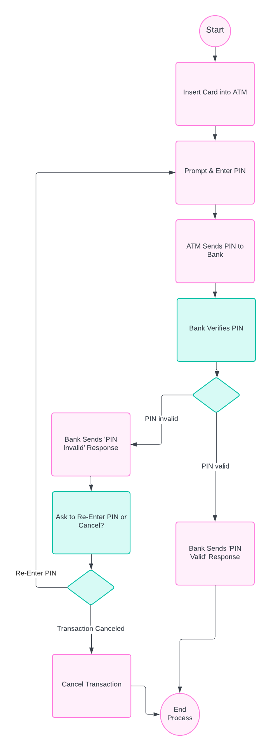

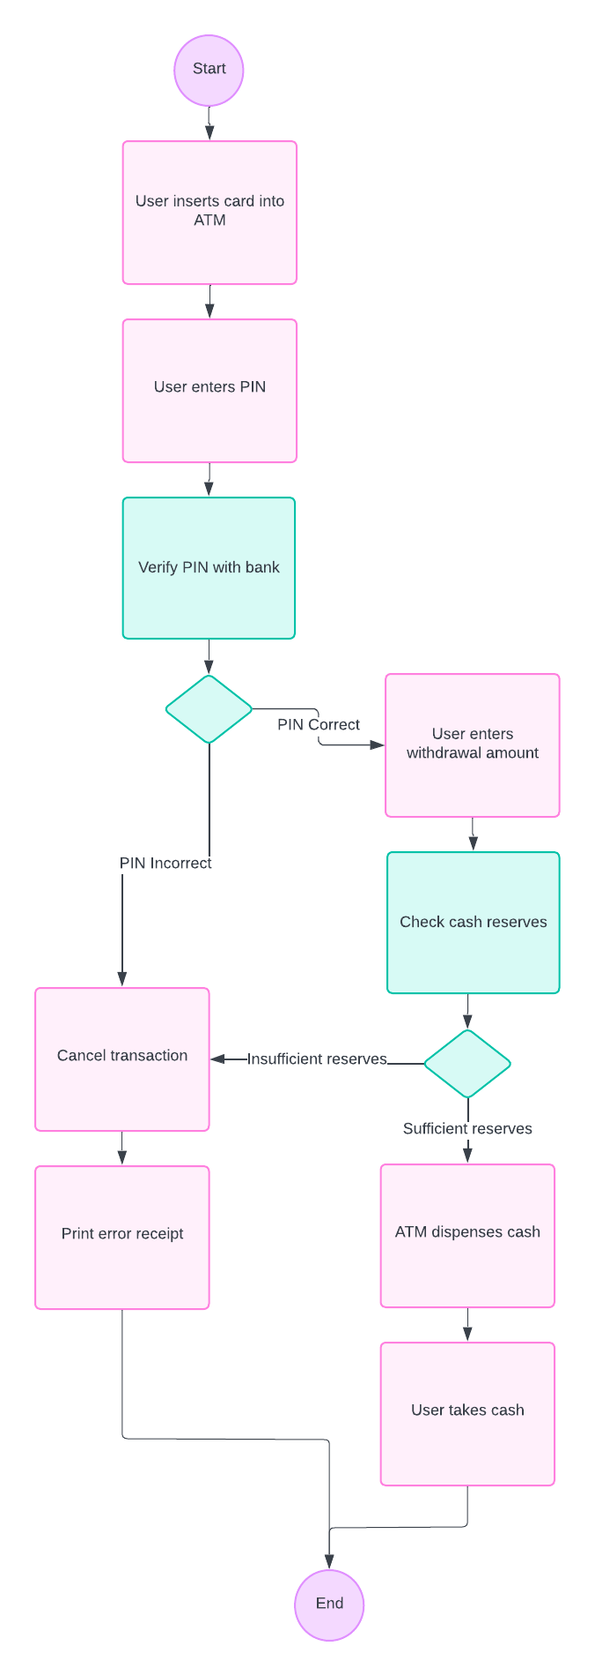

### UML Sequence Diagram

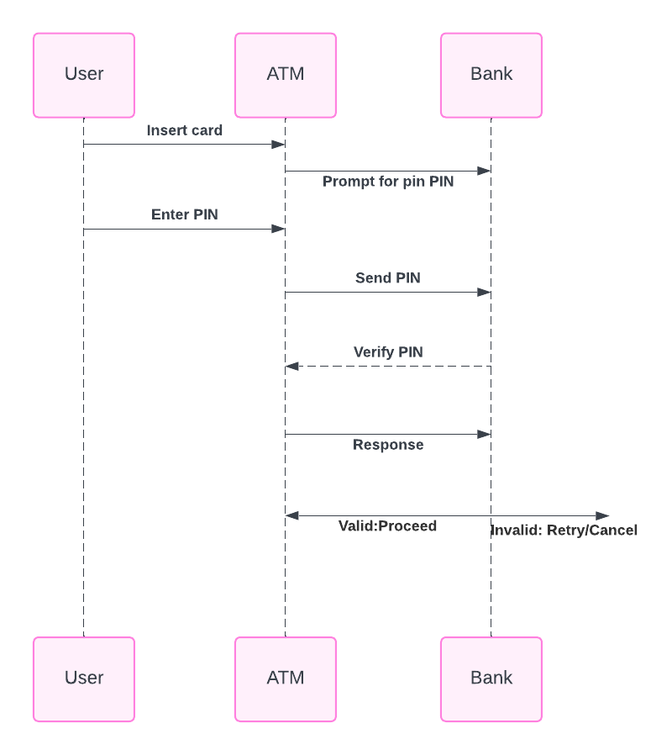

### UML Class Diagram

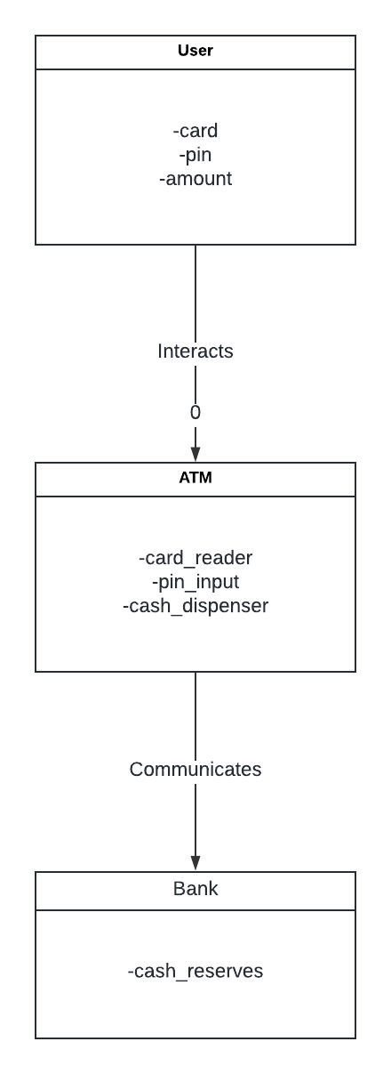

## Technical Requirements

***Hardware Requirements:***

1. ***ATM Machine****:*
   * *Card reader for reading user cards.*
   * *PIN input pad for users to enter their PINs.*
   * *Cash dispenser for dispensing cash.*
   * *Receipt printer for printing transaction receipts.*
   * *Display screen for user interaction.*
   * *Network interface card (NIC) for network communication with the bank server.*
2. ***Bank Server****:*
   * *High-performance server for handling multiple ATM requests simultaneously.*
   * *Secure storage for user PINs and account information.*
   * *Network interface for secure communication with ATMs.*

***Software Requirements:***

1. ***ATM Software****:*
   * *User interface software to guide users through the transaction process.*
   * *Card reader driver for interacting with the card reader hardware.*
   * *PIN pad driver for reading user input from the PIN pad.*
   * *Cash dispenser driver for controlling the cash dispensing mechanism.*
   * *Communication software for securely sending and receiving data to and from the bank server.*
2. ***Bank Server Software****:*
   * *Database management system (DBMS) for storing user account information and transaction records.*
   * *Security software for encrypting and verifying PINs.*
   * *Application server software for processing ATM requests and interfacing with the database.*
   * *Network security software (firewalls, intrusion detection/prevention systems).*

***Tools:***

1. ***Development Tools****:*
   * *Integrated Development Environment (IDE) for software development.*
   * *Version control system (e.g., Git) for managing code changes.*
2. ***Testing Tools****:*
   * *Automated testing tools for validating the software functionalities.*
   * *Load testing tools to ensure the system can handle multiple concurrent transactions.*

***Infrastructure:***

1. ***Network Infrastructure****:*
   * *Secure communication channels between ATMs and the bank server.*
   * *Redundant network paths to ensure continuous operation in case of network failures.*
2. ***Power Infrastructure****:*
   * *Uninterruptible Power Supplies for ATMs and bank servers to handle power outages.*
3. ***Physical Security****:*
   * *Secure locations for ATMs to prevent tampering.*
   * *Surveillance systems to monitor ATM locations.*